🔁 What is Partial Autocorrelation (PACF)?
Imagine you’re trying to predict tomorrow’s temperature based on past days.
- Autocorrelation (ACF) tells you how today’s temperature is related to previous days, like yesterday, the day before that, and so on.
- But ACF looks at the total effect, which includes both direct and indirect relationships. So, the relationship between today and 3 days ago might be affected by the influence of yesterday and 2 days ago too.
🔍 Enter PACF: Partial Autocorrelation
PACF helps you isolate the direct relationship between today and a past day — let’s say 3 days ago — removing the effects of days in between (like day 1 and day 2).
✅ Simple Analogy:
Think of it like this:
- You want to know how much influence your grandma (Lag 3) has on your personality without your mom (Lag 1) and dad (Lag 2) getting in the way.
- PACF removes the influence of your mom and dad, and tells you only what grandma brings to the table.

🔢 Technical but Simple:
- ACF (Autocorrelation Function): Tells you the correlation of the series with all previous lags (including indirect ones).
- PACF (Partial Autocorrelation Function): Tells you the pure correlation with a specific lag, excluding the effects of the lags in between.

📊 When to Use ACF vs PACF?
- Use ACF to see how much past values generally influence the current value.
- Use PACF to identify the right number of lag terms to include in models like AR (AutoRegressive) models.
For example:
- In an AR(p) model, look at PACF to decide how many past values to include (the “p”).
- In an MA(q) model, look at ACF to decide how many moving averages to include (the “q”).

⚡ Summary Table:
Feature | ACF | PACF
What it shows | Total correlation with past lags | Direct correlation with a specific lag
Includes | Both direct & indirect effects | Only direct effect
Use in models | Useful for MA models | Useful for AR models

🔍 Why are ACF and PACF Graphs Important?
When you want to build a time series model, like an ARIMA model, ACF and PACF graphs help you decide:
- What type of model to use (AR, MA, or both)
- What lag values (p or q) to choose for those models
Let’s go through each point now.

🟢 ACF Decreases Slowly → AR Model
“If the ACF graph decreases slowly and approaches 0, it indicates the AR model.”
Simple Explanation:
When the correlation drops gradually as the lag increases, it means past values have a lasting influence.
That’s typical of an Auto-Regressive (AR) model — where the current value is based on its own past values.
Analogy:
Like your mood today is still affected by how your whole week has been — not just yesterday.

🟣 ACF Drops Sharply at Lag 1 → MA Pattern
“If the ACF chart shows a sharp decline at lag 1 and then approaches 0, this indicates the MA pattern.”
Simple Explanation:
If the correlation is strong at lag 1 and then suddenly disappears, it suggests that only the recent error or noise matters.
That’s typical for a Moving Average (MA) model — where the current value is based on past errors, not values.

🔵 PACF Drops Sharply at Lag p → AR(p)
“If the PACF chart shows a sharp decline at a lag (i.e. p) later and then approaches 0, this indicates the AR pattern.”
Simple Explanation:
A sharp cutoff in the PACF graph after lag p means only the last p values are directly useful.
This helps you pick the order of an AR model, written as AR(p).

🟠 PACF Decreases Slowly → MA Model
“If the PACF chart is slowly decreasing and approaching 0, this indicates an MA pattern.”
Simple Explanation:
A gradual decline in the PACF means the error terms from many previous time points are affecting the current value — a sign of an MA model.

🧊 Blue Shaded Area = Confidence Interval
“The blue shadow graph seen in these graphs is the confidence interval.”
Simple Explanation:
This is like a “safe zone”:
- If a spike (bar) goes outside the blue area, it means that autocorrelation is statistically significant.
- If it’s inside, it might be just random noise.

🔁 Repeating Patterns = Seasonality
“If there is a pattern that repeats at specific intervals in the ACF and PACF graphs, this indicates seasonality.”
Simple Explanation:
If you see the same spikes every 12 lags, for example, it likely means monthly seasonality in yearly data.

📉 Slow Drop in ACF + Sharp Drop in PACF → Non-Stationary Series
“While the autocorrelation slows down in the ACF graph and sharply decreases after a certain lag in the PACF graph, this usually indicates that the series is not stationary.”
Simple Explanation:
This pattern often suggests that the mean or trend is changing over time.
In time series, this is bad because non-stationary data breaks the assumptions of ARIMA-like models.

✂️ Solution: Differencing
“For such a series, the difference operation can make it stationary.”
Simple Explanation:
“Differencing” means subtracting the previous value from the current one:
df['diff'] = df['value'] - df['value'].shift(1)
This helps remove trends or seasonality to make the series stable.

🧾 Final Summary:
Graph Behavior | Likely Model | Explanation
ACF drops slowly | AR | Past values still influence the present
ACF drops sharply at lag 1 | MA | Only recent errors matter
PACF drops sharply at lag p | AR(p) | Tells you how many lags to include in AR
PACF drops slowly | MA | Suggests an MA model fits well
Spikes repeat every few lags | Seasonality | Cyclical patterns (e.g., monthly, quarterly)
ACF slow drop + PACF sharp drop | Non-stationary | Differencing may be needed
Here are the ACF and PACF plots for four types of time series:

- AR(1) Process:
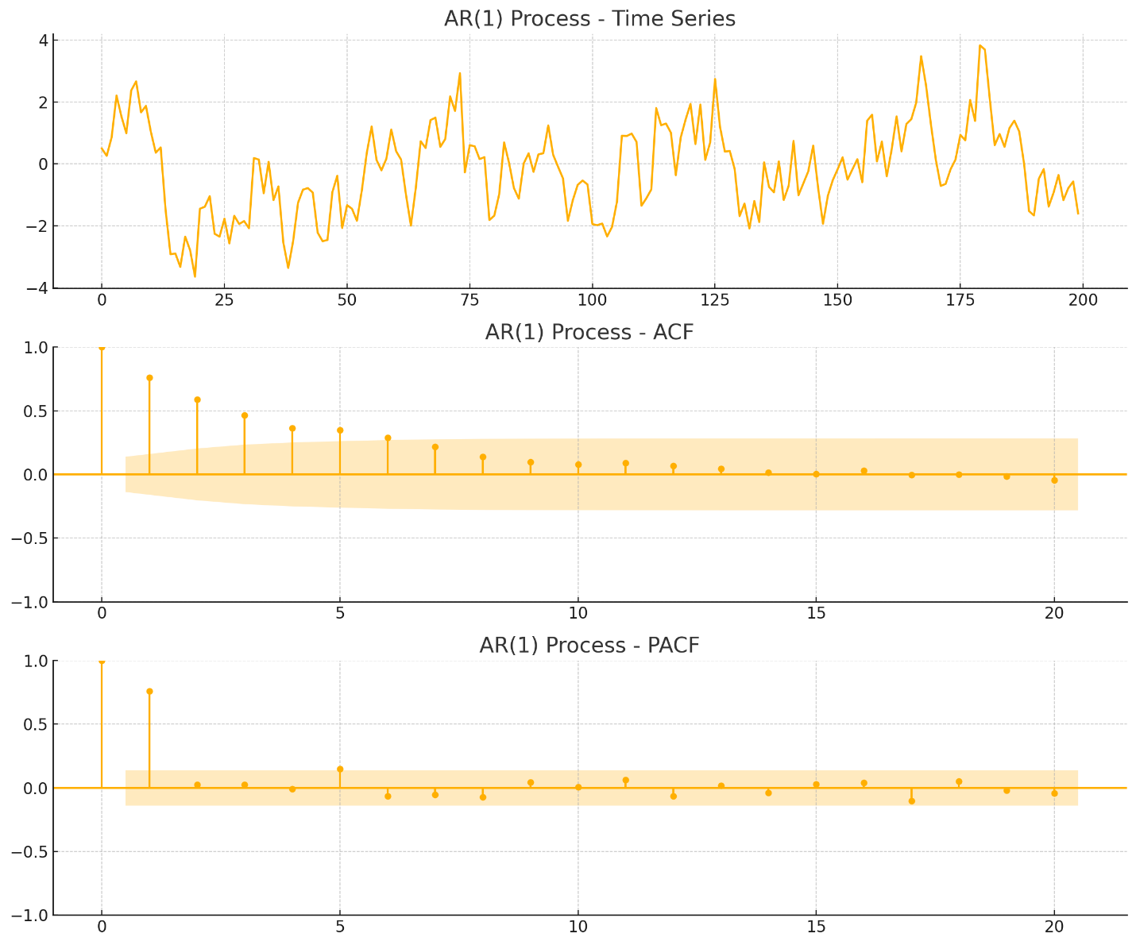
  - ACF gradually declines → AR pattern.
  - PACF cuts off sharply after lag 1 → confirms AR(1).
- MA(1) Process:
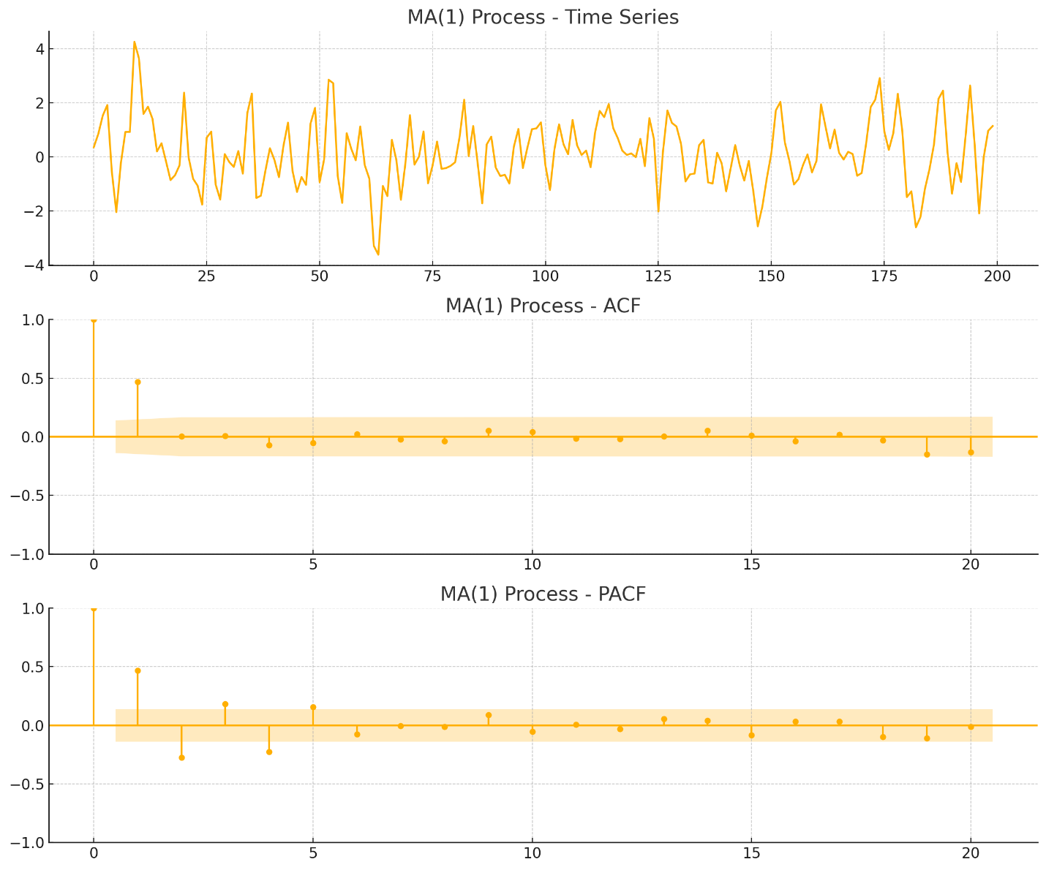
  - ACF cuts off after lag 1 → MA pattern.
  - PACF declines gradually → confirms MA behavior.
- Seasonal Pattern:
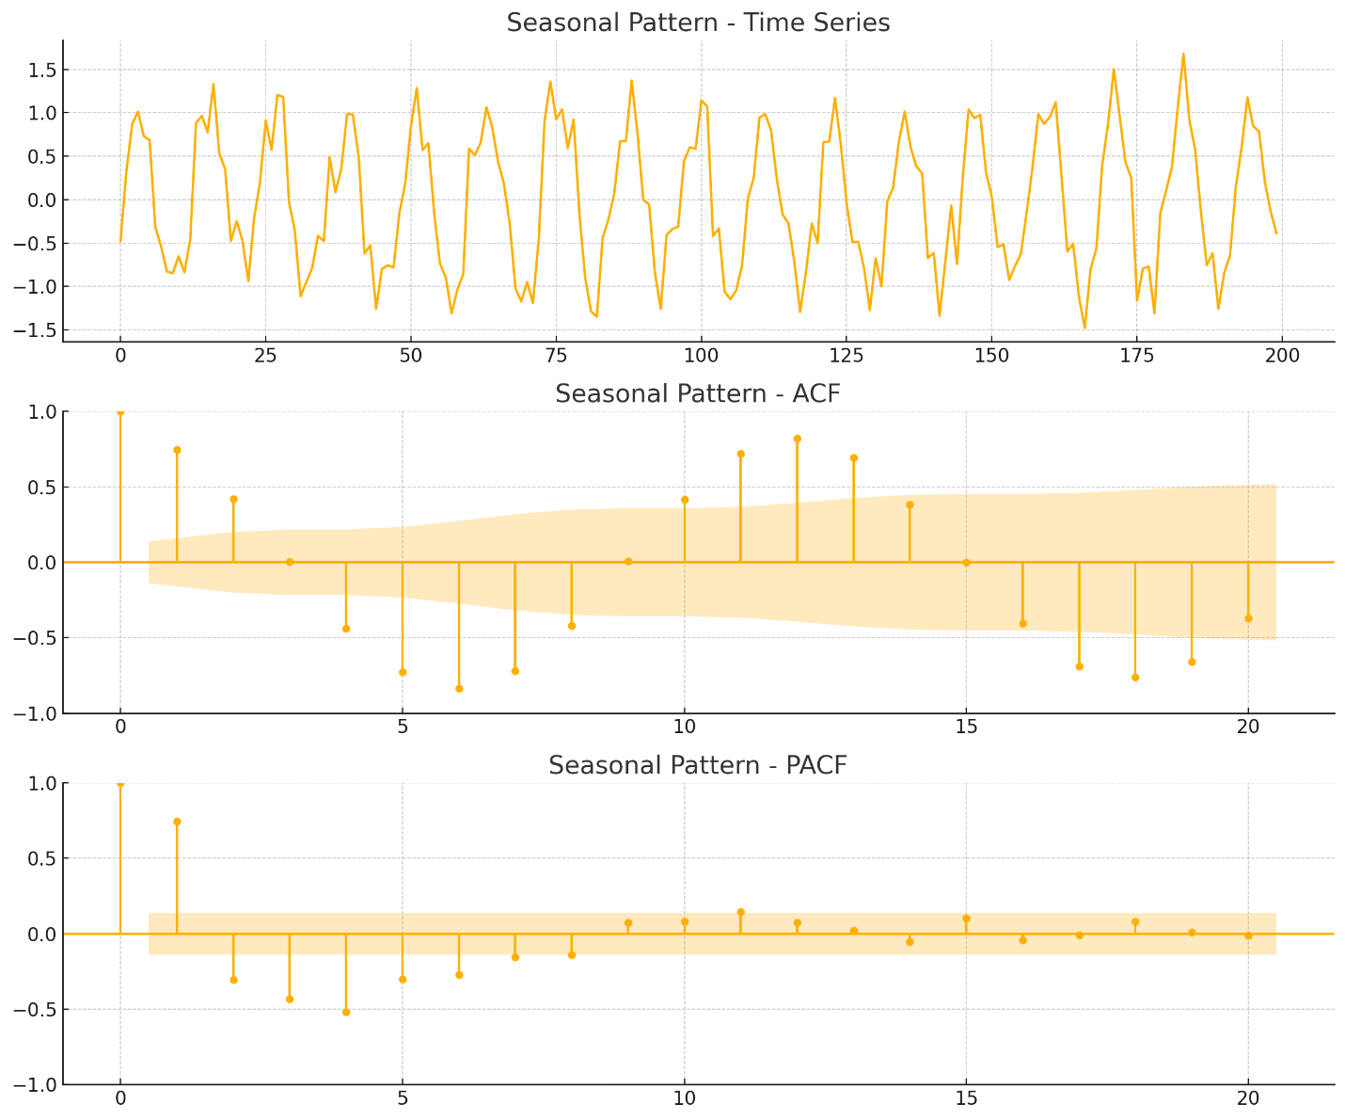
  - ACF and PACF show repeating spikes (e.g., every 12 lags) → clear seasonality.

📌 Step 1: Understanding what we’re doing
Before we build a time series model (like ARIMA or SARIMA), we need to set the parameters that tell the model how to understand and predict our data. Instead of guessing, we try to decide these parameters based on plots and patterns we observed earlier — like ACF and PACF plots.

🧱 Step 2: Stationarity and Differencing
"Since the series has become stationary by taking both trend and seasonal differences, we will define 𝑑 = 1 and 𝐷 = 1"
- Stationary means the data doesn’t have trends or seasonality anymore — it’s more stable, which models like ARIMA need.
- We made the data stationary by:
  - Removing the trend (with one regular differencing → d = 1)
  - Removing the seasonal pattern (with one seasonal differencing → D = 1)

🔍 Step 3: Using ACF to find MA and Seasonal MA
"In the ACF plot, significant lags are observed at 1, 2, and 7. Therefore, the MA(q) parameter can be 2, and the seasonal MA(Q) parameter can be 1."
- ACF (Autocorrelation Function) helps identify MA (Moving Average) parts of the model.
- When we see spikes at lags 1 and 2, it suggests an MA(q) of 2.
- A spike at lag 7 (which matches our seasonality period) suggests adding a seasonal MA(Q) term of 1.

🔍 Step 4: Using PACF to find AR and Seasonal AR
"In the PACF plot, significant lags are observed at 1, 2, 7, 14, and 21..."
- PACF (Partial Autocorrelation Function) helps identify AR (AutoRegressive) parts.
- Spikes at lags 1 and 2 → choose AR(p) = 2.
- Even though there are seasonal lags (7, 14, 21), it’s usually safer to ignore the seasonal AR (P) unless really necessary — to avoid making the model too complex.

⚖️ Step 5: Adjusting Based on Results
"Some sources suggest adding a seasonal MA(Q)... However, trials showed that setting AR(P)=1 provided a lower error..."
- Some experts say: if seasonal lags are negative in ACF, add seasonal MA (Q) and set seasonal AR (P) to 0.
- But in this case, experiments showed that using AR(P)=1 worked better — with less error and better R² score.
- So, we trust the results and set P = 1 (even if it’s not what general advice says).

✅ Final Model Parameters
So we get:
- Non-seasonal ARIMA:
  - AR (p) = 2
  - Differencing (d) = 1
  - MA (q) = 2
→ ARIMA(2,1,2)
- Seasonal part (with seasonality = 7):
  - Seasonal AR (P) = 1
  - Seasonal differencing (D) = 1
  - Seasonal MA (Q) = 1
  - Seasonality = 7
→ SARIMA(2,1,2)x(1,1,1,7)

